**SOUTH-SOUTH KNOWLEDGE EXCHANGE: KENYAN DELEGATION VISITED THE ETHIOPIA SUSTAINABLE LAND MANAGEMENT PROGRAM**

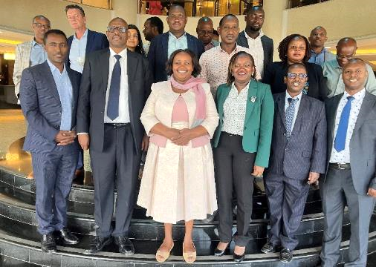**Addis Ababa, Nov 11, 2023** — The Kenyan delegation has conducted a south-south knowledge exchange visit to Ethiopia with the aim to learn key lessons from the Ethiopia Sustainable Landscape Management (SLM) Program that will help the design of an effective and responsive Program on watershed improvement Services for Kenya. The knowledge exchange team has discussed with the Natural Resources Management Directorate of the ministry of agriculture, Resilient Landscape and Livelihoods Project (RLLP), Climate Action through Landscape Management (CALM) and Green Legacy Initiative (GLI) team and visited activities that focus on natural resource management from 7-10, November 2023.

Figure 1: The Kenyan delegates with the Ethiopian team

H.E. Prof Eyasu Elias, the state minister for the natural resource sector of the Ministry of Agriculture in Ethiopia, led the discussion with the Kenyan delegate and provided a welcoming and introductory remark describing the historical background, efforts and key achievements attained by the country along with the policy backups and partners that are supporting the country’s effort toward natural resources management.

In his introductory remark, H.E. Prof Eyasu elaborated that in the past fifteen years, Ethiopia has been working under the framework of Ethiopia Sustainable Land Management Investment Framework (ESIF), which is a strategic framework to undertake SLM interventions and mitigate the natural resources degradation. He further emphasized that since 2018 the government of Ethiopia (GoE) has launched the GLI which is a national afforestation/reforestation program that contributes to climate change mitigation and rehabilitation of degraded landscapes.

Brief introduction on the SLM activities that have been undertaken since 2008 in three phases has been presented to the participants by Mr Habtamu Hailu, the Resilient Landscapes and Livelihoods Project Coordinator. The Water Land Resource Center (WLRC) of the Addis Ababa University, which has designed the SLMP knowledge base, also presented how the digital knowledge base system is supporting the planning, reporting, and learning of the SLMP.

As a follow-up to the state minister's introduction, Mr Tefera, CEO, Natural Resources Management Directorate, presented the GLI and the sustainable land administration efforts along with the overall progress, and its contribution to the environment.

Additionally, Dr Yitebitu Moges (PhD), Director of Climate Science Research Directorate at the Ethiopian Environment and Forest Research Institute (EEFRI), introduced the Kenyan delegation to major forest programs and projects, including the Oromia Forested Landscape Project (OFLP), the RLLP, and CALM, which are enhancing the GLI and restoring the environment.

Dr. Yitebitu Moges has further elaborated restoration and forest management activities by the OFLP, which has laid the foundation for the recently launched Emission Reductions Purchase Agreement (ERPA) of Ethiopia.

Besides attending a series of briefings from the Ethiopian team, the Kenyan delegation have also presented their plans to design a forest landscape restoration program in Kenya and raised questions to see how the Ethiopian experience would fit to their context. Detailed explanations have been given by the SLMP and other project/ program teams regarding the major components of the sustainable land management program, including its goals, strategies, implementation plans, and monitoring and evaluation process. The team also discussed the contribution of land administration and second level land certification to the sustainability of natural resource management and management, and Ethiopian forest transformation program, overall successes and challenges of the environment programs and the plans for scaling up the program in the future.

Following the briefing session on the first day, the delegates visited two watersheds in Sidama Regional state where they stayed for three days and met the RLLP regional coordinator, technical experts and the community. The field visit has given them an opportunity to observe the implementation status of SLM activities and discuss with Community Watershed Teams, Development Agents, Community Facilitators and beneficiaries of the project.

The Kenyan delegates indicated that the visit has enabled them to gain insights into the Ethiopian Sustainable Land Management Program, and the policies and best practices that have been implemented. Furthermore, they explained that the experience from Ethiopia's SLM program was indeed motivational, and they had acquired lessons to design similar environmental programs in Kenya. They further noted that the complementing projects, implementation arrangement and achievements from the program were very practical and will be useful for their own initiatives.

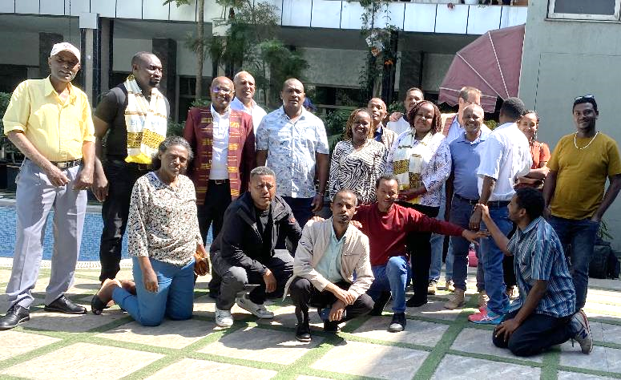

Figure 2: The Kenyan delegation and the RLLP team after the field visit in Hawassa city

***